Mrs. From’s
Recommended Supply List
The following supplies would be beneficial in helping your child become organized and better prepared for class.
- Reusable water bottle
- 3-ring binder (1.5") with a clear pocket cover
- dividers for binder
- Accordion folder (at least 5 sections)
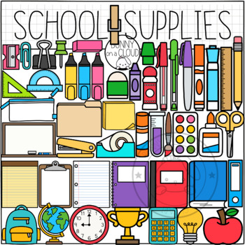
- 5 composition books
- Homework folder
- glue sticks
- scissors (preferably adult size)
- erasers
- Pencils, pencils, pencils
- Highlighters
- Kleenex
- antibacterial hand gel
- pencil pouch
- pencil sharpener (for your desk)
- 1 fine-tip black Sharpie
- 2 red pens
- crayons/markers/colored pencils
- 3 x 3 post-it notes
- dry erase markers (and something to erase with)
- ear buds (not wireless)
- lined notebook paper
- ONE BIG SMILE

Other Classroom Community Donations
- Pencils
- Clorox wipes
- Sandwich Ziploc bags
- Quart Ziploc bags
- Gallon Ziploc bags
- Expo markers
- Sharpies (black and colored)
- Kleenex
- Paper plates
- Individual wrapped candy (Dum Dum lollipops, Jolly Ranchers, Starbursts, and/or Lifesavers)
- Prizes for class auctions

